PRESIDENT'S OFFICE
REGIONAL ADMINISTRATION AND LOCAL GOVERNMENT
FORM FOUR NORTH WESTERN ZONE MOCK EXAMINATION SEP. 2024

031/2B PHYSICS 2B PRACTICAL
TIME 2:30 HRS 02/10/2024 WEDNESDAY

INSTRUCTIONS
01. This paper consist of two (2) question
02. Answer all question
03. Each question carries 25 mark
04. Non- programmable and mathematical table may be allowed
05. Write your examination number on every page of your answer sheet.
06. The following constant may be used
- Gravitational constant g = 10N/kg
- Pie 𝐴 = 𝜋 = 3.14
- The aim of this experiment in figure 1 to determine mass Mo of the meter
rule provided.
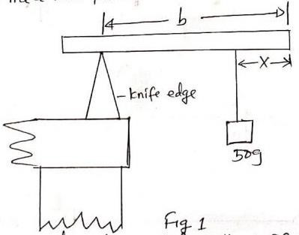

- Place a meter rule provided on the knife edge. Balance the meter rule and record the value of Lo
- Hang 50g mass to a position where x = 10cm, 15cm, 25cm, 30cm, 40cm, and 45cm, Measure the corresponding value of “b” when the meter rule is balanced.

- Plot of the graph of b (on vertical axis ) against x (on horizontal axis)
- Find the slope of the graph above
- From the following relationship SMO + 5 = 1 where
50
S = Slope then calculate mass Mo
- State any source of error with corresponding precaution to be taken in doing this experiment.

- Your provided with a resistance box R, a dry cell E, a switch S, a jockey J
and a Centre – zero galvanometer. They were required to determine the
value of the unknown resistance x by means of a meter bridge as follows
      - Set up the circuit as shown in figure 2
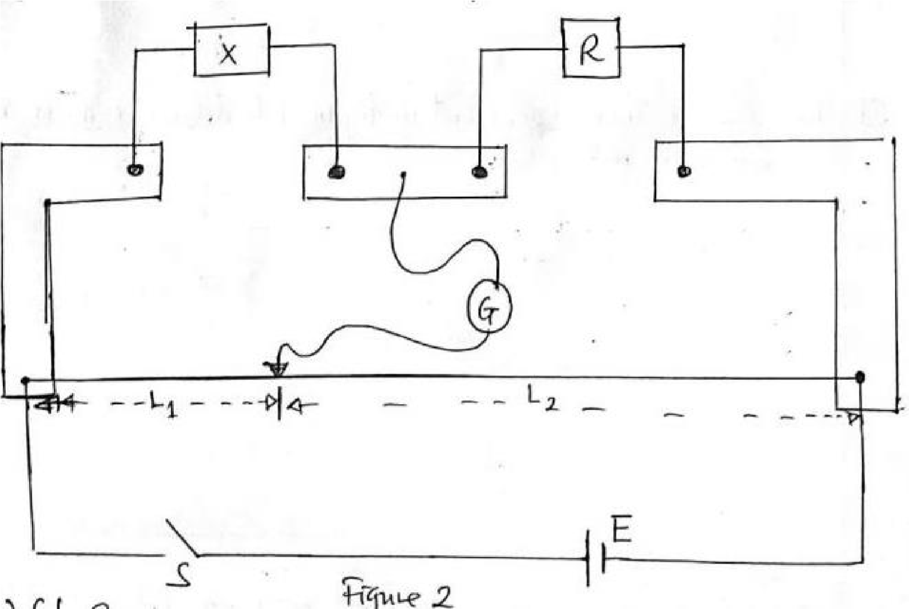
      - Set R 1Ω, close the switch, slide the jockey over the meter bridge wire until the galvanometer reads zero. Read and record the length L₁. Also read and record the corresponding length L₂
      - Repeat the procedures in 2 (b) for values of R = 2, 3, 5 and 7 ohms and record the corresponding values for L₁ and L₂ in each case.

QUESTIONS
  - Tabulate your results including the values of L₁
L₂
  - Plot a graph of R against L₂
L₁
  - Find the slope s of the graph
  - Determine the value of the unknown resistance by showing clearly how you arrive at your answer.

